Tasks

L01: a

**FitZone Fitness Center.**

**Introduction for the organization.**

The fitZone fitness center is recently opened gym in kurunegala that plans to provide fitness services via an engaging online application. Class schedules, personal training information, membership, sing-ups, service requests, and blog entries about health and fitness will all be made easier by the web system.

**Analyzing similar web systems.**

Before planning new web application for fitzone fitness center web Page, analyzing similar web system will be very important. It’s help for getting more understandable:

* How fitness and gym industry work.
* Identify design factors features to implement those sites.
* Getting user experience as a user.

The websites listed below were taken into consideration for comparison.

**Anytime Fitness: -** fitness enthusiasts, gym members and potential customers are the audience of these type industry. Anytime fitness has clean and modern type web site UI Design it’s easy to navigation and also responsive design this site has.

**Gold’s Gym: -** Design appearance and element including bold, dynamic layout and quality images and videos. Online registration, workout plans and nutrition tips are important features we can use.

**MyFitnessPal**: - is one of the most widely used health and fitness application worldwide, this site created to assist users in monitoring their food intake, level of exercise and general well-being.

Key features here:

* Food tracking.
* Exercise tracking.
* Nutrition tracking.
* Goals setting.
* Community support.
* Also, premium features.

Key takeaways from this analysis.

**User Experience:** Error handling improve useability, easy to navigation, search functionality.

**Design:** This web sites have clean and modern also mobile responsive user engagement.

**Features:** blog posters, training profiles, mangling classing schedules, can we get as a feature.

Analyzing those example websites, we can get a conclusion about what the functional and non-functional requirements are for FitZone fitness center website.

**Functional requirement.** *(What the system must do)*

1. **User Management.**

Managing uses here is important, we can see several users in this web site. Most important users are customers (Members) because they are the people mostly visited this site. This website can provide blogpost, healthy recipes, meal plans etc.

* **FR1**: Allow users to register/create accounts (email/password or social login)
* **FR2:** Update Profile/ Change Password
* **FR3**: Enable login/logout functionality with password recovery
* **FR4**: Role-based access (Member, Trainer, Admin)

1. **Booking and Membership.**

* **FR5:** Show the Basic, Premium, and VIP membership plans together with their costs and perks
* **FR6:** Online membership sign-up and payment processing
* **FR7:** Calendar-integrated class/trainer booking system

1. **Content Management.**

* **FR7:** Show the time, length, and trainer of the classes
* **FR8:** Show the equipment list (organized according to your design)
* **FR9:** Post blog entries about nutrition, exercise, and success stories.

1. **Interaction.**
   * **FR10:** Email-notification contact form for questions

* **FR11:** Tracking logged-in users' progress (weight, exercises)

1. **Features for the Administrator**.

* **FR12:** Member, class, and content management dashboard
* **FR13:** Capacity to reply to user questions

**Non-functional requirement.**

* 1. **Useability-** user friendly UI/UX design.

Web design should be mobile, Tab, responsive (supports all screen).

ADA – compliant accessiability (keyboard navigation, alt text)

* 1. **Performance**- Less than two second for page load and navigation each

Pages.

Support 500+ concurrent users during peak hours.

* 1. **Security-** Encrypt sensitive data (PCI compliance for payments/ users login password).
  2. **Reliability-** Automated backups (daily).
  3. **Scalability**- Cloud-hosted architecture to handle member growth

**Mockup Layouts (designs).**

The web application for fitZone fitness center has the mockup diagrams shows below. The layout of the important pages is shown visually in these graphics. Every mockup coming with a synopsis outlining its characteristics and function.

**Home** **Page**.

Introduce to user to the gym and highlight key features.

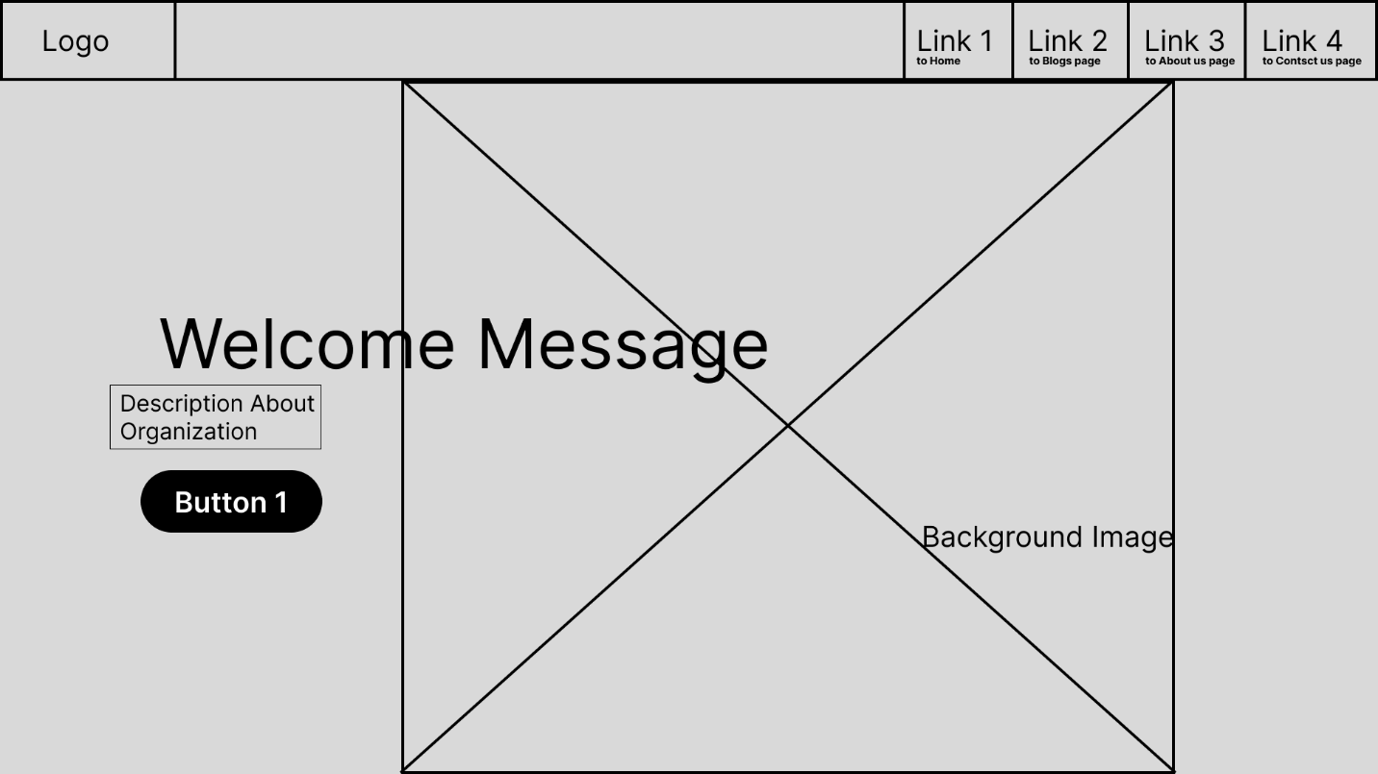

Here **Navigation Bar** link to FitZone fitness center Blog page, about us page, also contact us pages.

Link 2: Navigate to the Blog page, in there have all food schedules GYM members need to follow and also detail about cardio, strength training, yoga, Online program about workout and calisthenics members able to join it.

Link 3: Navigate to About us page, here users can get FitZone fitness center information line History about FitZone Fitness center, contact details, News and Updates and Social media Links.

And, click **Button 1** is navigate to the Login Page, users can Login with FitZone center official web page.

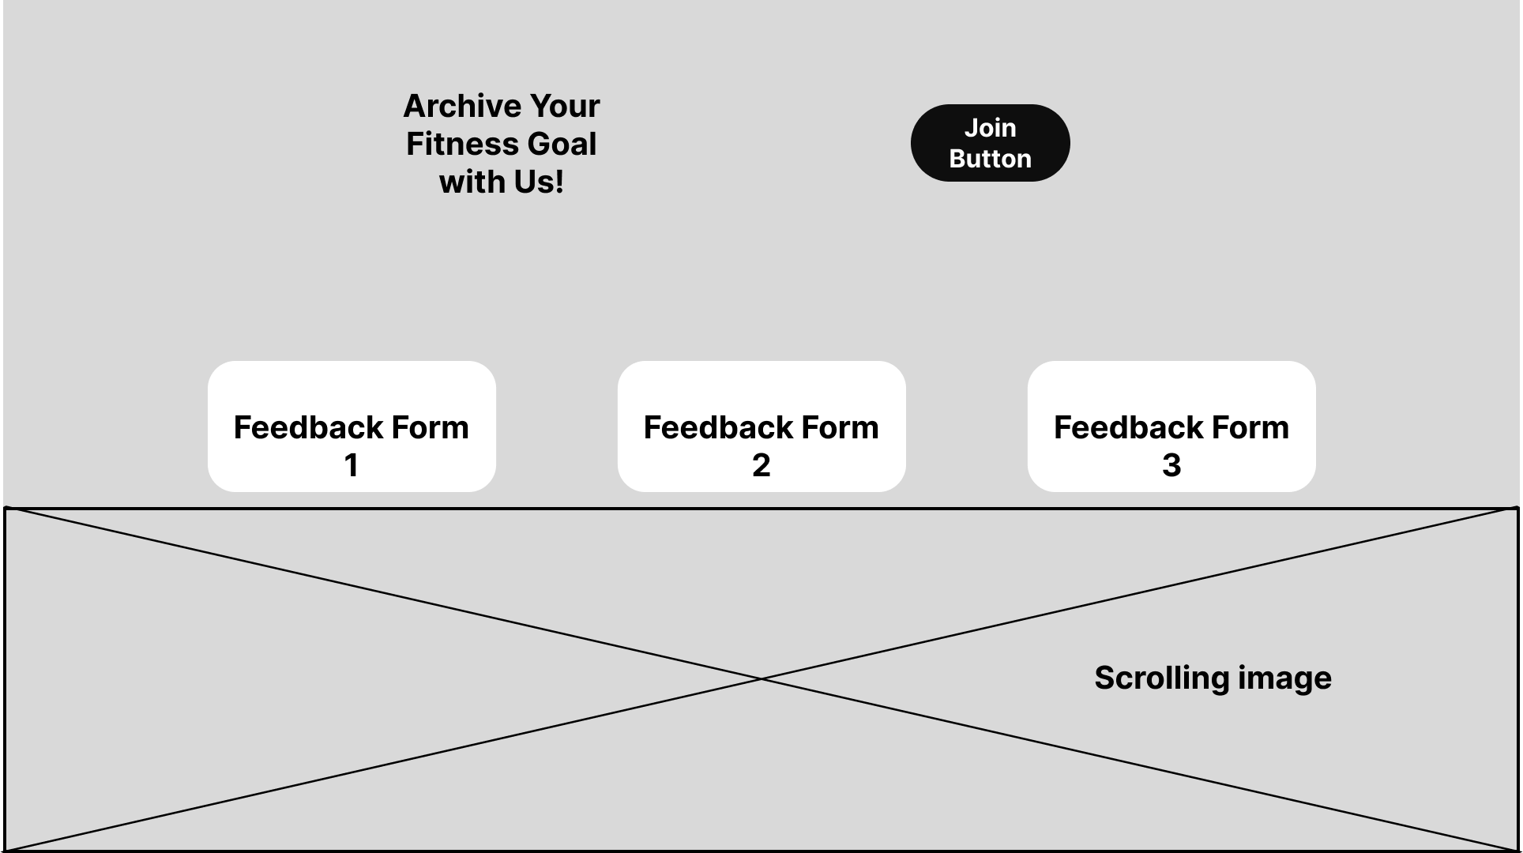

Here click Join Button, users can navigate to the Registration Page, there users able to Fill FitZone official Registration form and Make a payments, for the Membership Plans.

***Scrolling down in the home page users able to see three boxes. These boxes navigate to each page.***

1. **Membership plans.**

These boxes navigate to each page and uses can see Membership plans and buy it. FitZone fitness center have 3 types of gym membership plans. Basic, Premium and VIP each membership plan has own benefits and facilities.

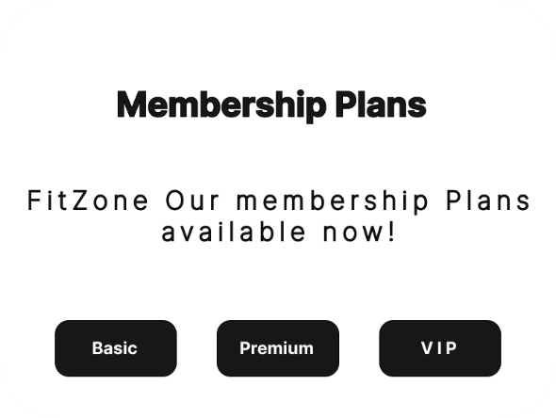

1. **Class Schedule.**

Click this box user able to see our Training program schedules and what time period they can choose.

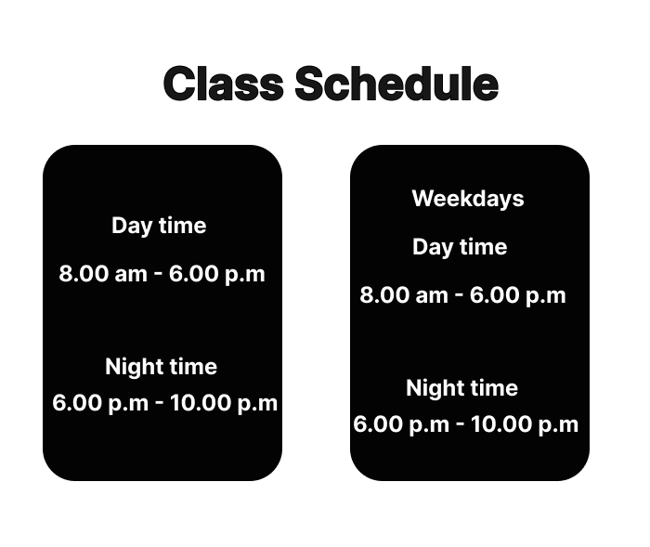

1. **Training Programs and Trainers Details.**

Here, we including our all-Training programs and Personal Trainers Details.

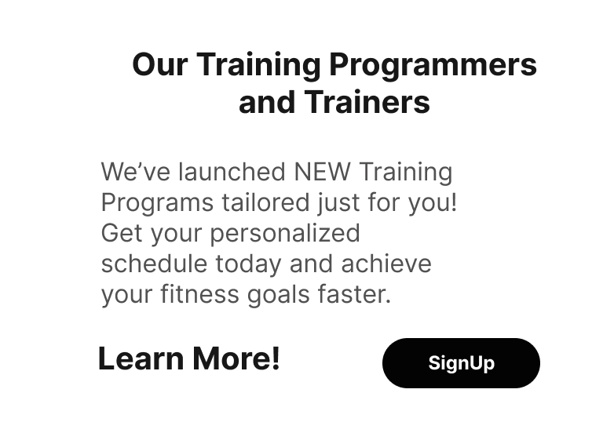

**This is all a component you can see on the home page mockup layout design.**